# 

# Mario party Final Report

## ReadRecommend

Harry Lording [h.lording@student.unsw.edu.au](mailto:h.lording@student.unsw.edu.au) (z5164744) (Scrum Master)

Jarrod Cameron [jarrod.cameron@student.unsw.edu.au](mailto:jarrod.cameron@student.unsw.edu.au) (z5210220) (Developer)

Sihao Shen [sihao.shen@student.unsw.edu.au](mailto:sihao.shen@student.unsw.edu.au) (z5239042) (Developer)

Zac Parsons [z.parsons@student.unsw.edu.au](mailto:z.parsons@student.unsw.edu.au) (z5165177) (Developer)

Zihao Yu [zihao.yu@student.unsw.edu.au](mailto:zihao.yu@student.unsw.edu.au) (z5135085) (Developer)

Submission date: 6/08/2020

# 

# Overview:

API: <http://ec2-13-239-96-113.ap-southeast-2.compute.amazonaws.com/>

Website: <http://ec2-13-239-96-113.ap-southeast-2.compute.amazonaws.com/index>

### Architecture

The system is relatively simple. It has a flask-python web-server serving all its requests. A general non-developer user will likely only interact with its JavaScript front end that is served via this flask web-server. Also hosted on this web server is a rest API with an sql database that is used to do all data queries and additions. This setup also allows for developers to create applications on-top of our database as the API is exposed to the user. This setup also allows for good scalability as the web-server can be load-balanced later down the line and the sql database can be moved to a distributed storage solution.

### Design

Minimalistic themed styling that also catered for flexibility and ease of use for the user was central to the design we wanted to deliver in our system.

The overall visual design direction was to keep the website minimalistic with a theme colour. This would mean that the front-end styling had flat elements where different menus were defined for the most part by white on off-white colour contrast. We took this direction as it is currently a popular trend in styling of websites, and the css implementation of these design features require only simple and reusable css styling. This means we were able to use this time on implementing more functionalities for the system.

The visual design direction also enhanced the ease of use in the system. Elements are clearly defined by contrasting colour boxes, and large text for headings and subheadings direct the reader. Text sizes were always also kept to a readable size and boldness was added for important links.

Ease of use also was a critical success factor for our front end design. Whenever a user came across an object in the system (such as a book, user or collection) that object had a link attached to it, so the user could navigate to that object's dedicated page and to access its full information. A sidebar navigation window is available on the website. This side bar features on every page (bar login and register), so at any time the user can access the most important features in the website. These are only a couple examples of the ease of use functionality can be seen across the system. A further look into the design of the system can be viewed in the user manual section.

# 

## 

# Functionalities and Implementation Challenges:

## Packages and licensing

### Used packages

* Axios - a http client package used for talking with the flask-restplus API from the javascript front end. Axios simplifies the HTTP request sending and receiving process and this is why it was chosen.
* Select2 - it is a jQuery based replacement for select boxes. This makes it easier to create select boxes in JavaScript.
* AnyChart - a JavaScript library for cross-platform data visualization in the form of interactive charts and dashboards.
* Pandas - a sql like data library to simplify database queries and perform more complex analysis especially useful in the recommender.
* Sqlite3 - a library for creating an sql database and making sql queries. The library is very popular with lots of support and is easy to use and set up.
* Pyjwt - a library for creating jwt tokens for authenticating users.
* Flask - a library for creating a web server to serve all web requests in the system. Flask is very easy to use and given the support and popularity of the library. Our group also had prior experience with Flask.
* Flask - restplus - an extension of flask that simplifies the creation of a rest API and auto generates documentation for it. Flask-plus conveniently provides automatic documentation on all generated endpoints, simplifying and reducing the amount of code needed for API endpoints. Our group also had prior experience with Flask-plus.
* Numpy - a library for storing multidimensional arrays and improving functionality for these arrays

### Licenses and references

Fortunately, all the tools and packages we used in this project are open source and can be used without a permission. The references/citations for the third-party libraries is included in the references section at the bottom of this document.

## Functionalities

For the most part the functionality of our system followed the requirements from the specifications in the project description. However certain functionalities were added for certain requirements to expand on their functionality, or for the ease of use for users.

Additionally, entirely new functionalities were also added, namely, to follow users and create events in a social page. This allows users to see what collections the users they follow have and what events that users have. Below is a list of functionalities from the spec and how they are implemented.

### From spec and altered from spec

* **Users must be able to register and login using username and password credentials.**

This was implemented in the standard way, by registering a username and a password in the registration screen. The password is encrypted after registration. Upon logging in, which can only be done when the correct details are given, a token is passed back and forth from the front and back end to ensure the correct user is accessing the system. Whenever a user wants to access any other function of the system, their token must be retrieved to ensure that that user is still the active user.

The token will expire in a set amount of time to maintain security if the user were to leave the website page open for an extended period of time.

* **Readers must be able to add book to their “main” collection, which should include details about the book title, author(s), publisher, publication date, and category.**

All users have a main collection. A user is given a main collection on registration to ensure all users have a main collection. Users can add books to the main collection through the main collection page or by the book page of any book, which includes option to add the book to the main collection.

Once the book is added to the main collection it all its details can be accessed through a book link which takes the user to the book’s page where all the details of the book are. Not all the details of the book are kept on the collection page to keep the page from being overcrowded and the details being kept too small.

* **They must also be able to add "named" collections to their account, which should include a name defined by the reader.**

Users can create a collection that is not the main collection through the “plus” button on the user’s collection page. The user can input a chosen name for the collection that describes the collection. This collection then subsequently shows on the user’s collection page.

* **Regarding the multiple collections readers can have: they must be able to add or remove books to/from any of their own collections.**

Any collection that the user has, including the main collection and any other named collections they have created can have books added or removed from a collections specific page. This can be accessed from a user’s collections page which lists all their available collections.

From the add book to collection link in a specific collection page, the user is led to a add book to collection page. Initially all the books in the system were listed for the user to add, however it was impossible to display all the books in a single page. The search function (described below) was included in this page so the user can search under a set criterion for suitable books for the collection. For example, if the collection is for cooking, the user can search for books under the cooking category, which will give cooking books to add to the collection.

To make it easier for a user to add books to a collection, this has been extended by added a “add to collection” option in the page for each book. This means the user can conveniently add a book to any collection if they have accessed a book at any page in the site.

* **Readers must be able to view a list of their collections, and click into any of these collections to view the books they contain.**

As mentioned above, users have a collections page, where all of their collections they have, including main and any named collections, can be accessed. Accessing the collection will take the user to that specific collection page, which gives the user insights into the books in that collection.

* **In addition, readers must also be able to look through the books contained in the collections of other users (eg: given another user's username).**

A user can access another user’s collections in multiple ways. For convenience, if a user comes across another user on the website (e.g. through the social pages) they can access their user’s page and see a list of their collections and access a restricted version of a specific collection page, which means that cannot modify the collection (i.e. they cannot add or remove books into the collection).

A user can also find another user's collection using a search function. A user can search another user’s name and be given a list of that user’s collections and again access a restricted version of the collection as described above.

* **They must also be able to view the top 10 most recently added books to any of their collections.**

In a collection’s page as well as seeing all the books in the collection, there is a section that lists the top 10 books that have been added to that collection.

* **To make it easier to find books, readers must be able to search for books by name or author, which should bring up a results list that includes a summary of the name, author, and year of publication for each matching book.**

A search function exists in the system. It has been expanded upon the spec however. Users can search for books by their name or their author, but they can also search books by categories, minimum ratings and keywords, to give the user more options to search for books.

A list of matching books includes the books cover, name, author, keywords, category and average reviews. Publication date was omitted as it was not considered as important information as the added aspects of the book. For example, as reviews are a critical part of the system, being the key component for making a book recommendation, it was added. More information than the information listed was considered too crowded for space.

* **Reading reviews can also help in selecting the right book to read, and readers must be able to add a review for any of the books that they've read, which should include a rating out of 5.**

In a book page, the user is able to leave a review. However, there are certain requirements needed to leave a review, including having read the book. This can be done by pressing the “read” button on the book page, which reveals a hidden “plus” button next to the reviews section to add reviews.

Upon clicking on the plus sign, the user is taken to the add review page where they can input a typed review and leave a rating out of 5. A typed review was deemed required to give the rating out of 5 context.

After the user leaves a review, the review is shown on the books page so other users can see the review.

* **Upon locating a book through any of the means provided by the platform, readers must be able to view its full details (including the book's reviews).**

Anywhere a book appears on the platform it is accompanied by a book link. This redirects the user to the book page of the book which includes the full details of the book.

Accompanying the book link (wherever it appears) is a brief description of important information of the book and the book cover. We excluded showing all the details of the book everywhere as we concluded that this overcrowded pages where books were included on the page.

* **The book's full details must also include the average rating for the book, based on all ratings given for the book.**

Wherever a book is accessed on the platform, its average review can be seen. The average review can also be found on the book page.

* **Apart from the average rating, readers must be able to see a total count of the number of readers that have read a given book.**

A more detailed breakdown is on the book page, which includes the number of reviews which have left a rating of 1, 2, 3, 4 and 5. This is presented in the form of a bar graph for easy viewing for the user.

* **To provide readers more help with finding the right book, they must be able to filter out any books from search results that are under a given average rating.**

To make the search function simply, a minimum average rating is a parameter in all searches, instead of being applied after a search is made. A user can also then search for books using minimum average ratings as the only parameter, finding all books with above that minimum rating. This provided for a more flexible approach for searching

* **They must also able to view recommendations for books to read based on: a selected book, and a selected recommendation mode.**

A recommendation function is accessible where a user can select a chosen book and then switch between different available recommendation modes. The chosen book is found using the search function, and the different recommendations modes are chosen using radio buttons, so the user can choose a recommendation mode outside of those provided.

* **A recommendation mode represents one way to calculate/determine what to recommend, and multiple modes must be offered.**

Multiple recommendation modes are offered. This includes by keywords, where the selected books keywords are string matched with all other books key words, ratings, where ratings of other books are compared to the ratings of the selected book (say if it is controversial this could be picked up), by author, and also by what users who have read the book have also read.

After the recommendation search is executed, a list of recommendations are provided in the form of books links (as described above) and the user can access these book’s book page and add them to one of their collections through the book page or check out the book’s reviews.

* **Readers must be able to set a goal for the number of books they'd like to read per month, and based on when books are added to their collections (or a "date-read" field defined when a book is added to a collection), show historically when they met their goal.**

The goal function was interpreted differently by our group. The spec suggests that adding a book to a collection signifies the user having read the book. In our eyes, adding a book to a collection was interpreted as having a book that the user would like to read or a book the user was interested in. In this case, what the spec required didn’t fit into our system.

As a result, we adapted the goal function. Whenever a user finds a book in the system, they are able to access the book and add a goal for each specific book. They are able to add a specific date that they would like to read the book by as well. The user can then have multiple goals for many books and plan out during the month what books they want to read and by when. If the users completes the goal it goes into their goal history page where they can view all their completed goals and goals which they have also missed, or are overdue.

This gives the user more flexibility with the goal function and allows them to organise their goals through specific books they would like to read. They can also retrospectively view all the books they have been able to read within their goal time and which goals they haven't been able to meet to adjust the time they have to complete future goals.

### Added functionalities

* **Social home**

A social home page available to the user which gives them a summary of all the users they follow, all the users that follow them and a list of events they have made and the events of the users they follow. On this page they are also able to follow and unfollow users in the followers submenu. They can also create and complete events on the events submenu.

This provides a central page for the user to organise all their social functions.

* **Follow users**

Users are able to follow users. This means they can directly access their user page through a link to their page that displays in the followers sub menu. They can then get a summary of their collections and events and can view their profile later for any updates to the user’s collections or events. Upon following a user, they also can see the events the user has made in their social home page.

* **Unfollow users**

If a user subsequently doesn’t want to be updated on a user’s collections or events, they can unfollow that user through a link in the followers submenu in the social home page. This will remove them from their followers list.

* **Creating events**

A user can create events that they and their followers can see. An event includes a book that the event has to do with, and title or description for what the event is about, such as “UNSW book club”, and a date for the time of the event.

Events are a central aspect of social functionality. Making events brings different users together, who want to participate in the same activities and read the same books.

* **Complete events**

Once an event is completed, the user who created the event can complete the event on their social home page. This will subsequently cause the event to disappear from all the users who follow that user’s social page.

* **User home page**

Each user had a home page. This is the central page for the website, and where users initially are located when they login. On this page is the user’s goals and recommendations for books based on what other users have read.

The user home page serves as a neutral page for where a user starts in the system, and where they can subsequently choose to navigate to other pages through the navigation side bar or by checking out recommended books.

* **Other user’s page**

Other user’s page serves to show a brief summary of what other users have created. It can be accessed when that user is found within the social functionality of the system. The brief summary is a list of their collections (which have links to the restricted collections page described above) and the events that that user has created.

This is for the convenience of the user, so a user can access all the content that a user has created in one location

* **Delete collections**

As well as being able to create collections, we thought it was suitable to also be able to remove collections that were no longer wanted by the user. This can be done of the user’s collections page, which has links for all the user’s collections and delete buttons next to each of those collections.

* **Side bar navigation**

Our system has seven different key functions in total that the user could use. To make it easier to navigate through the key functionalities of the system, a side bar navigation bar was added. This takes the user to the central page for each of the different functionalities which they can then delve deeper into to find all the functionalities of the area.

These include, home, my collections, find books, find collections, recommendations, social and log out.

* **Log out**

As well as being able to log in, we thought it was necessary to have a log out function. This allows the user to log out once they have done browsing the system or to change to a different account they may have.

This removes their existing token the user has been using to access their account, so that their account cannot be accessed after they have logged out.

## Technical / research / implementation issues

* Having little experience with front end development at the beginning of the project, the front end team didn’t know the methods of sending data from the front end to the back end. Flask was chosen as the application programming interface (API) because they had no prior knowledge about building a usable front end, and it is a well-known API with plenty of support and tutorial available.
* After some research, we chose to use Axios, a JavaScript library you can use to perform HTTP requests. At the beginning we tried to execute HTTP requests using the .fetch() function. However there are two steps in fetch, the first is to make the request and then the second is to call the .json() method on the response. By using Axios we were able to cut out the middle step of passing the results of the http request to the .json() method. Axios simply returns the data object we needed.
* To build a usable UI, we choose appropriate JavaScript and HTML functions to present the system information and where the user should give the input and how. However, because we lacked enough knowledge of front end development, it was very hard initially to implement the most basic of functions and there were difficulties describing the problems we were having to the rest of the team.
* For a proper UI/UX, CSS should be used for describing the presentation of Web pages. However, we did not have enough knowledge on how to use CSS and other styling to keep the UI/UX consistent and reflect the status of the system. Many attempts were made, for example, to keep all the buttons and links with one consistent style. All the the designs that were made in html (hardcoded) were very difficult to use / implement and the idea had to be scrapped.
* For some special function requirements, we needed JavaScript libraries to do what could be very difficult such as for the drop down menu, which would have been difficult to hard code in HTML and CSS . Different approaches were tested, one was directly using HTML and CSS to construct a drop down menu by ourselves, which was difficult, and needed constant adjustments when pages were altered. Later, with better research, we discovered select2 and jQuery to address this issue. For better presentation of rating of each book, we have decided to use AnyChart to make a bar chart.
* A good database was a crucial component of the final project. In the end we settled on an SQL database as we had some people familiar with SQL and it had a lot of easy integration with python libraries such as pandas that would help us perform the relatively complex queries required for the recommender system.
* We needed a good authentication system for the rest API to secure and authenticate any data coming in and out of the database. To do this we decided to use JWT tokens with a hash of a secret key and a random number generated when the server starts. This allows us to easily invalidate any tokens that we need to and will also give someone a different token every time they login (provided the server has restarted in that time). JWT tokens also let us identify every user on the requests they make which makes it easy to send the user personalised data and also easy to implement permissions.
* We wanted to have a decent rest API for talking with the database. This simplifies and expands functionality in the UI and also allows for developer applications to programmatically access information from our database. To do this we used flask-restplus as it automatically creates a swagger doc that developers can use.

## 

# User Document/Manuel

## Environment setup

Essentially all that is involved here is running the setup environment script (setupENV.sh). What it does is downgrade werkzeug for flask restplus and uninstall the default jwt so we can use PYjwt. Due to the way we have ports set up for use in our AWS server you will need to run the Flask.py in sudo, (run startServer.sh). The other thing you should do is run refreshdb.sh once to load our sample data.

IE If you would like to test outside of our implementation outside of our AWS server i would recommend the following.

./setupENV.sh

./refreshdb.sh

./startServer.sh

And that should set up our server with dest data. You can test a login with:

Username: john password: john

## Front end user manual and directions

For the most part, these screenshots are functionally reflective of our final submission, however the final submission may have minor styling changes.

## User login page

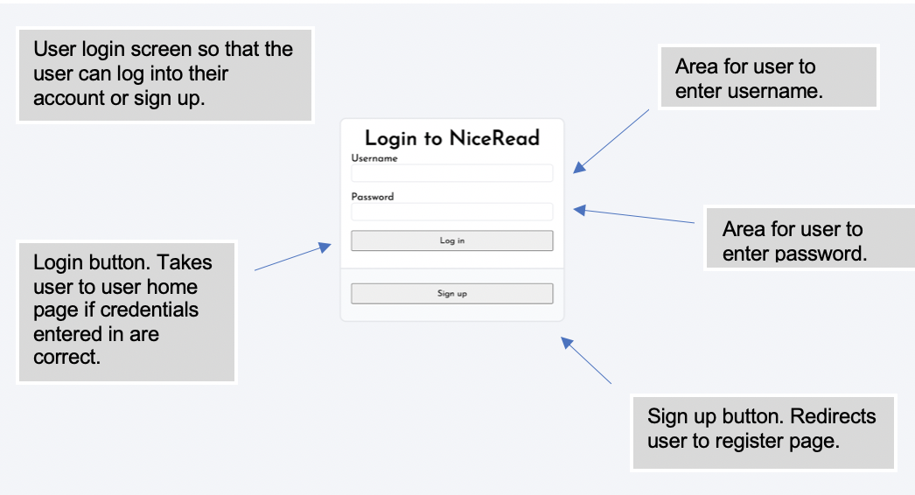

## Register page

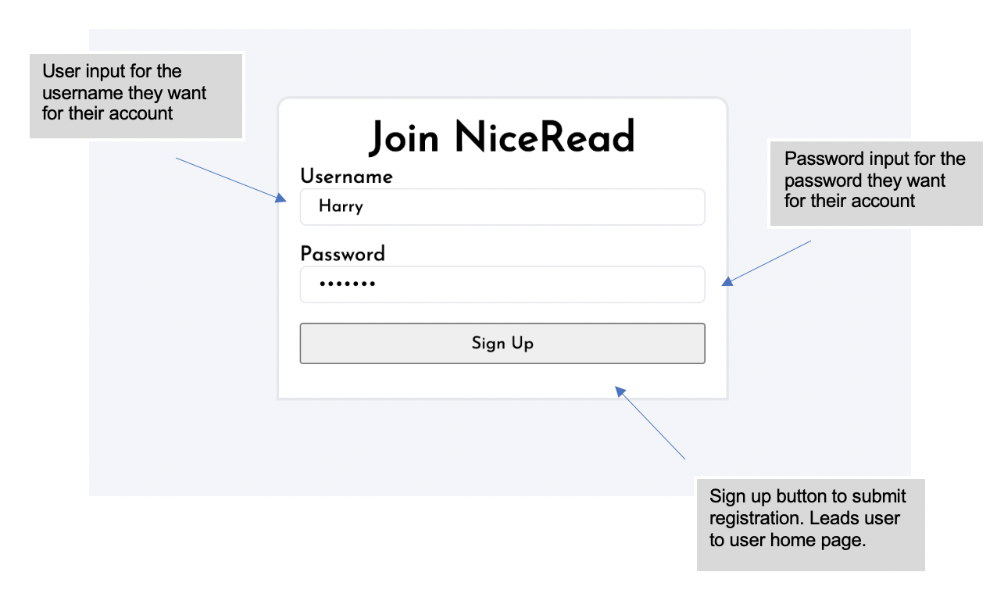

## User home page

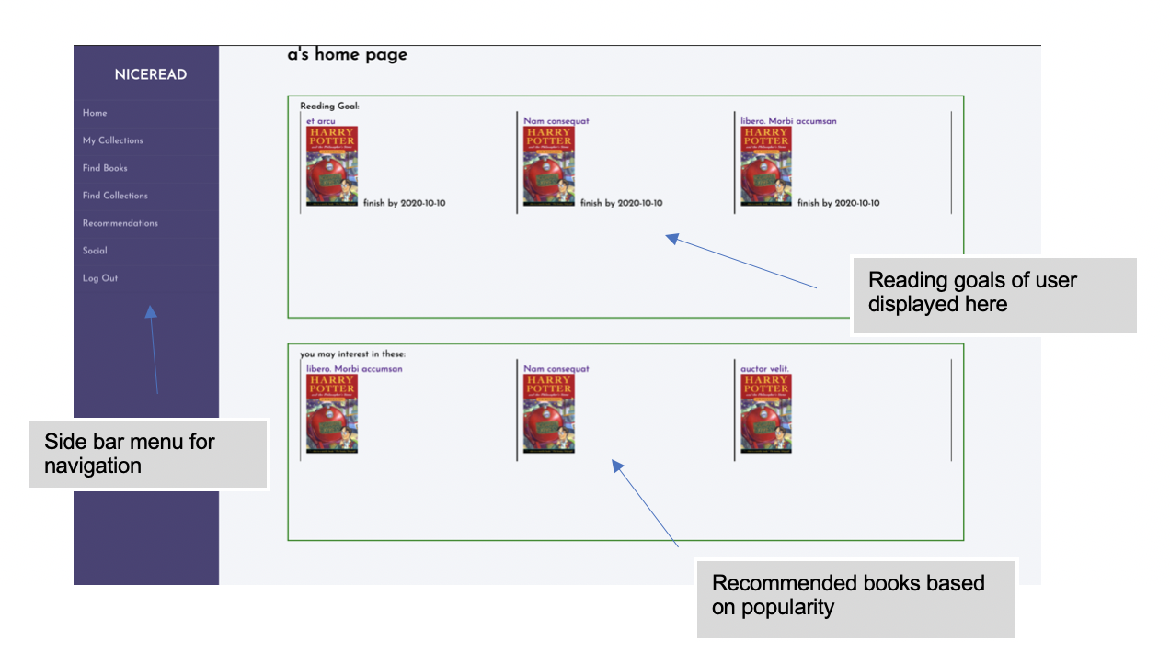

## Side bar navigation

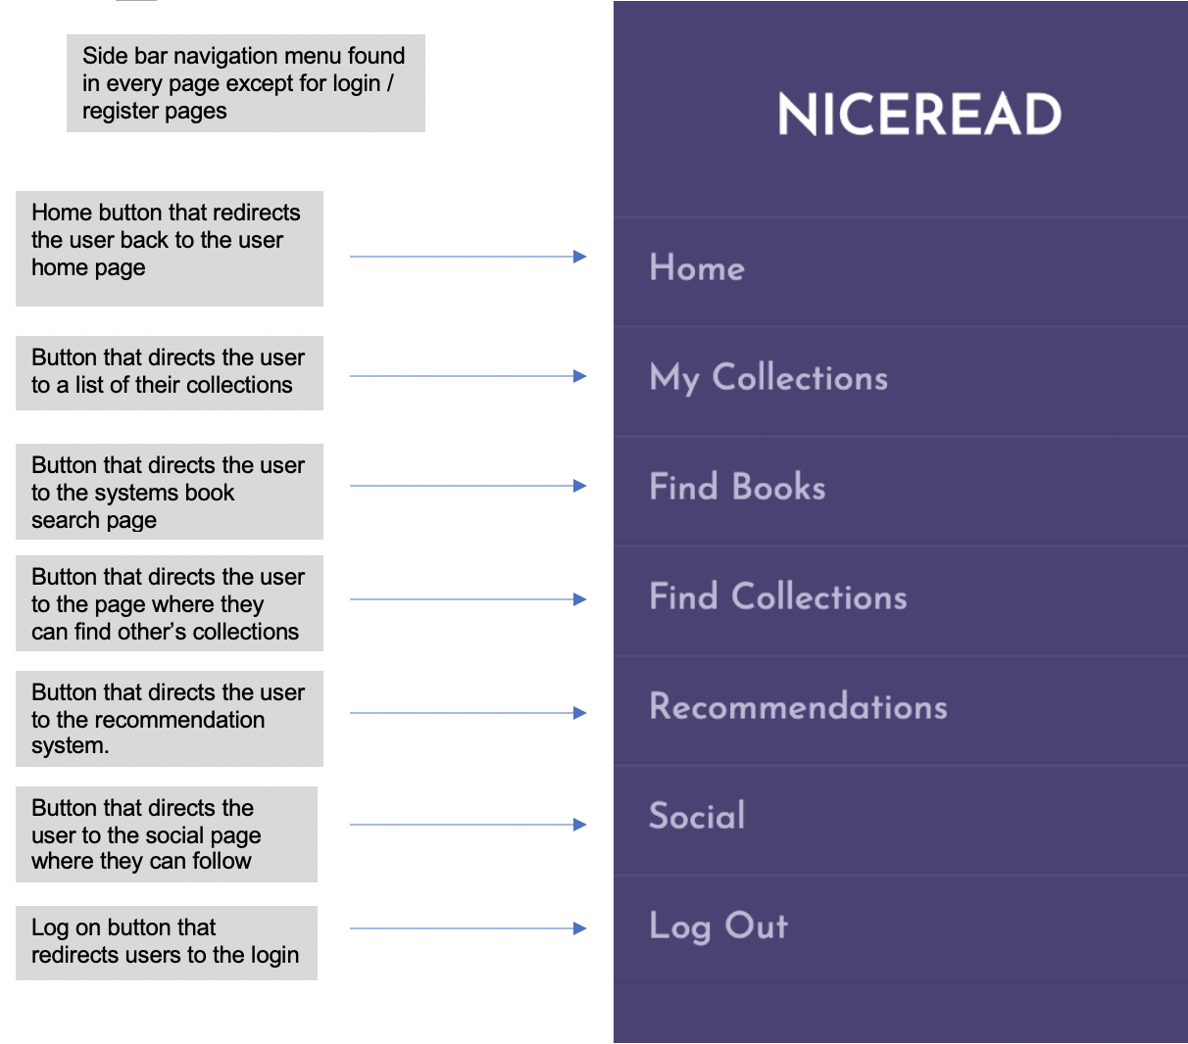

## Users collections page

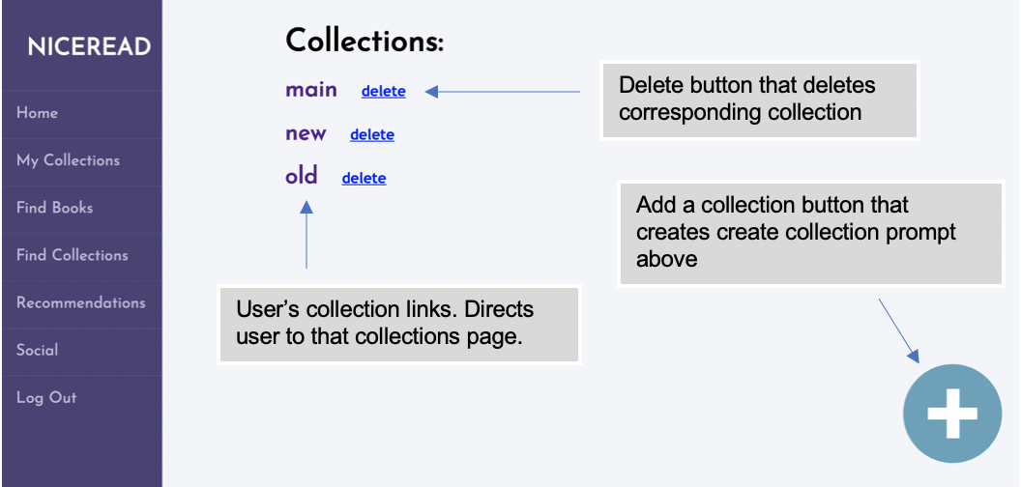

## Create collection prompt

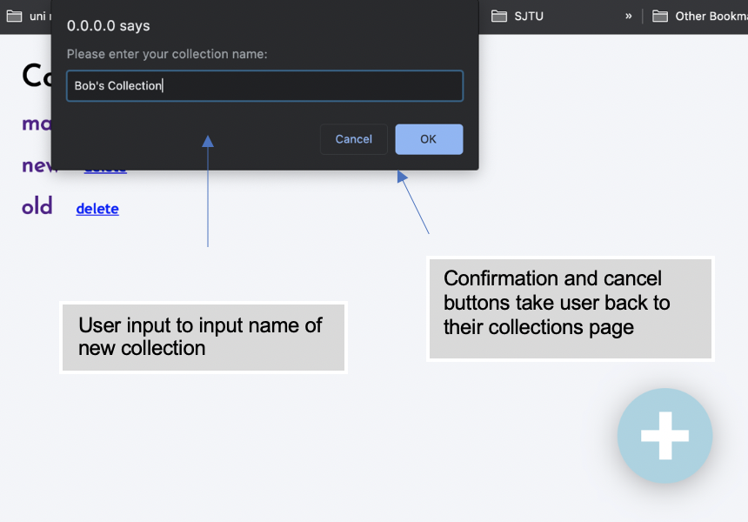

## Specific collection page

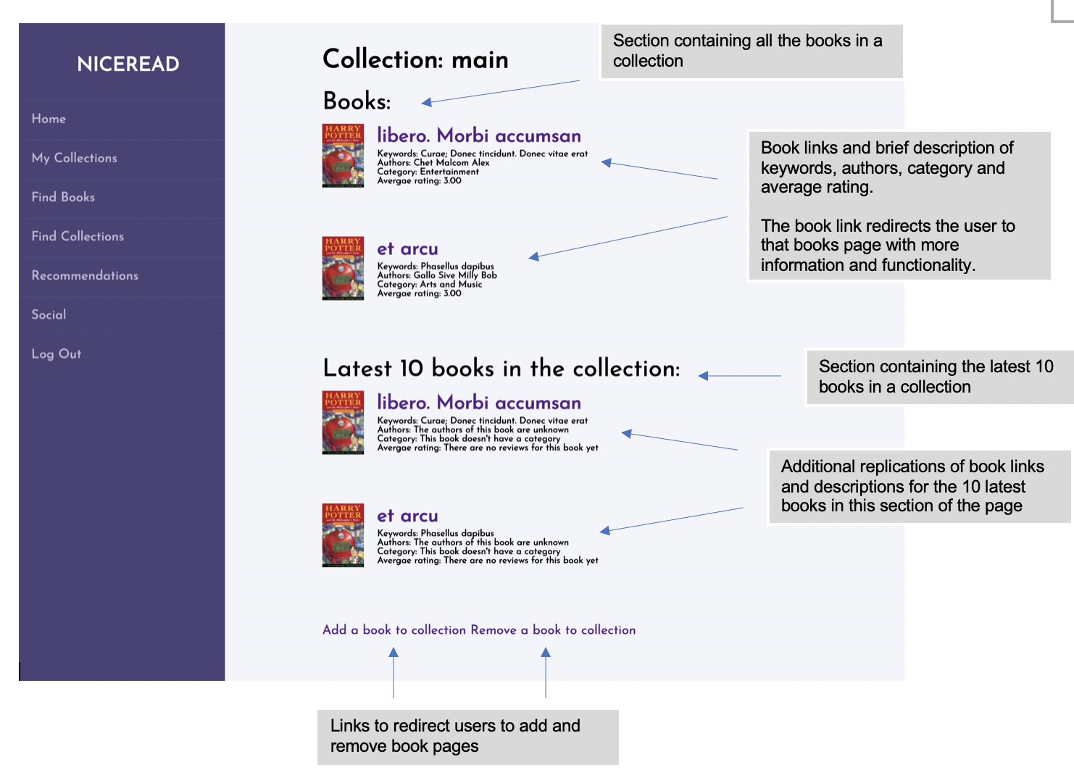

## Add book to collection page

The page uses the same layout as the search page but the book links created add the books to the collection chosen, instead of redirecting uses to the book page.

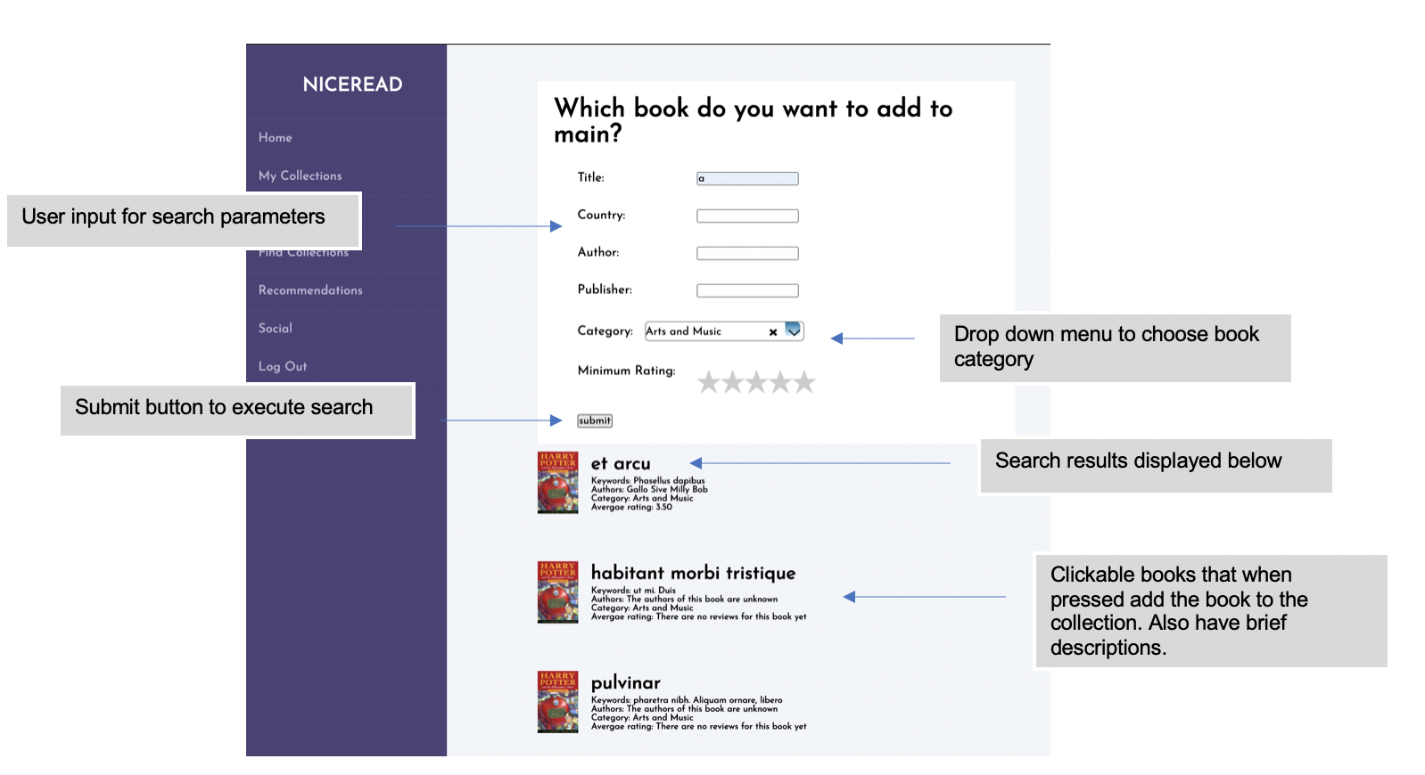

## Add book to collection page

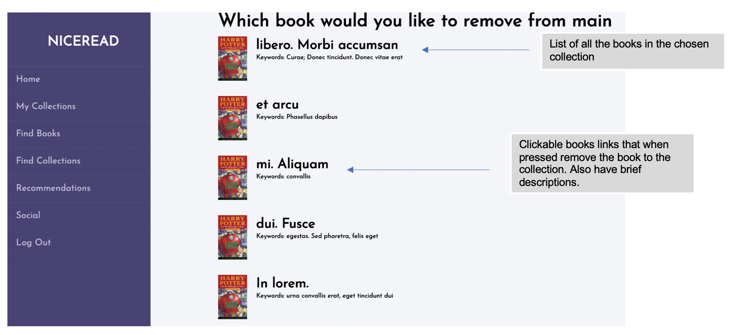

## Book page

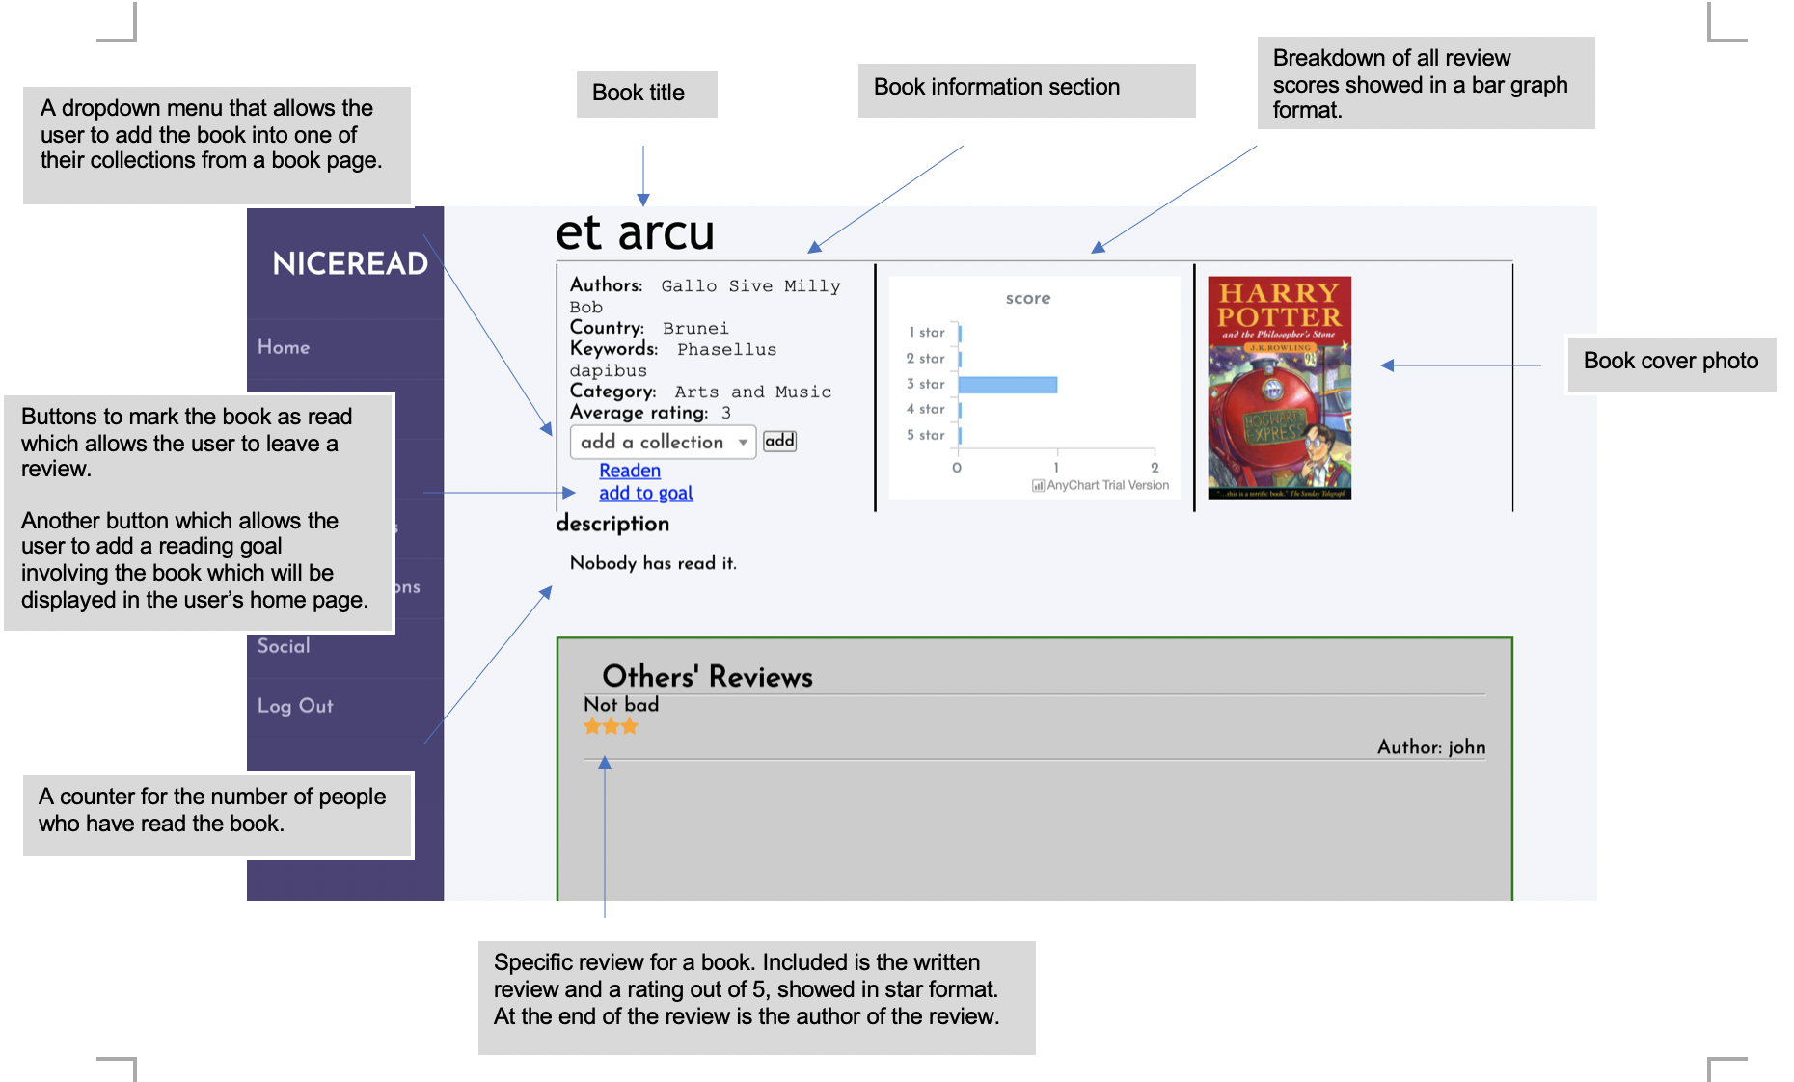

## Book page continued

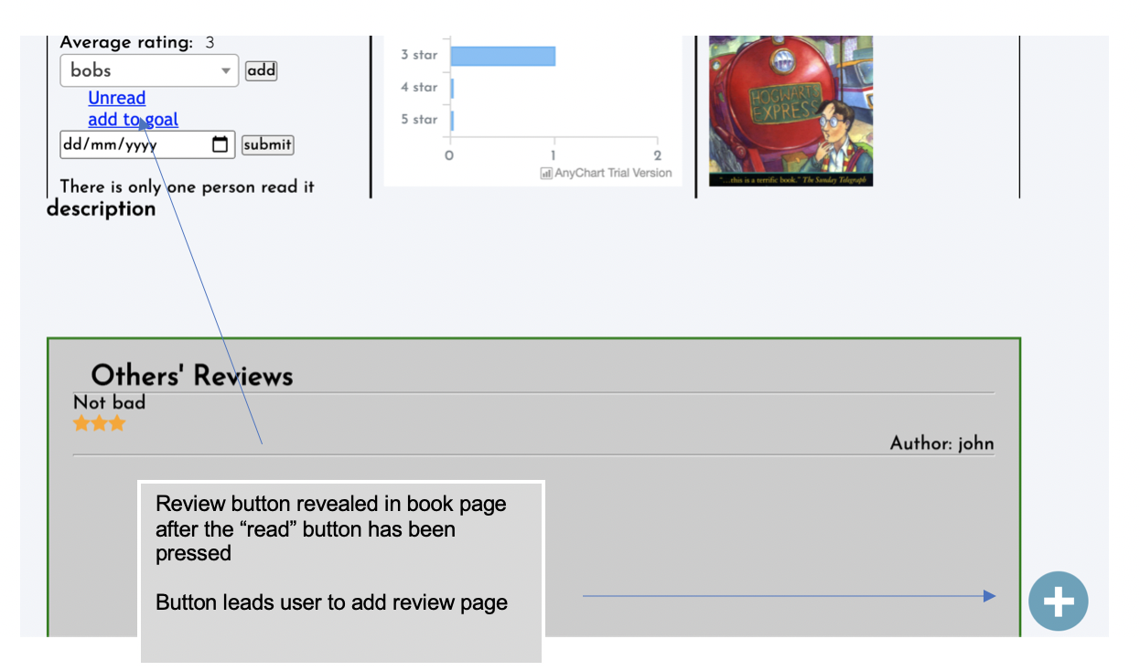

## Review page

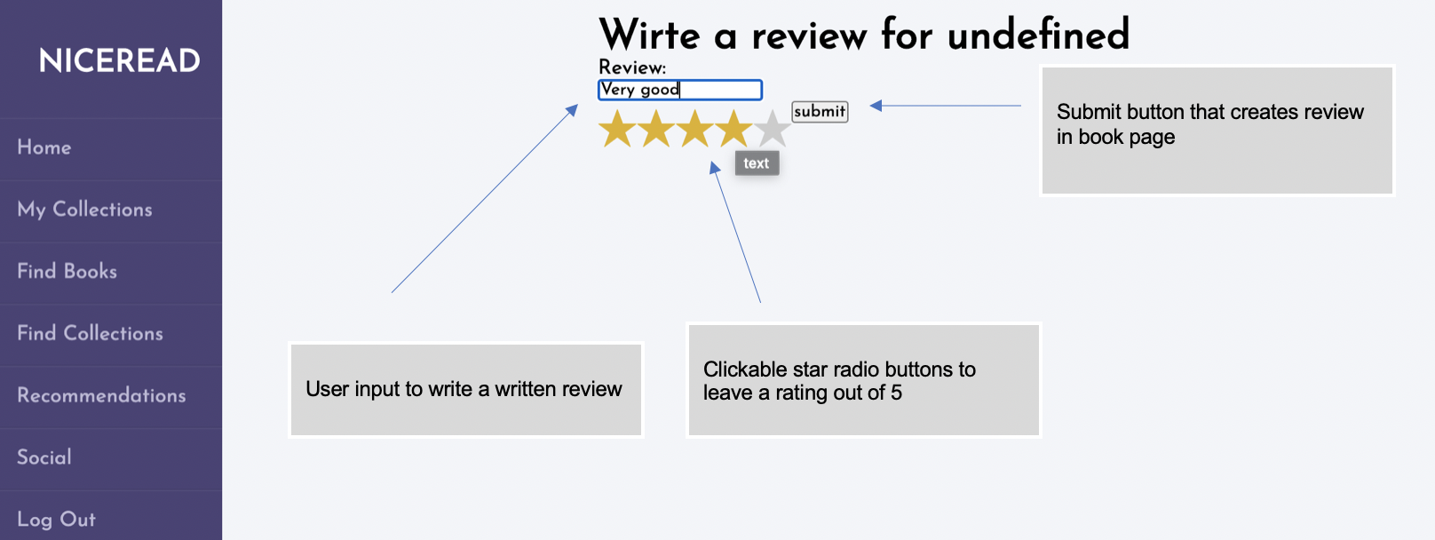

## Search page

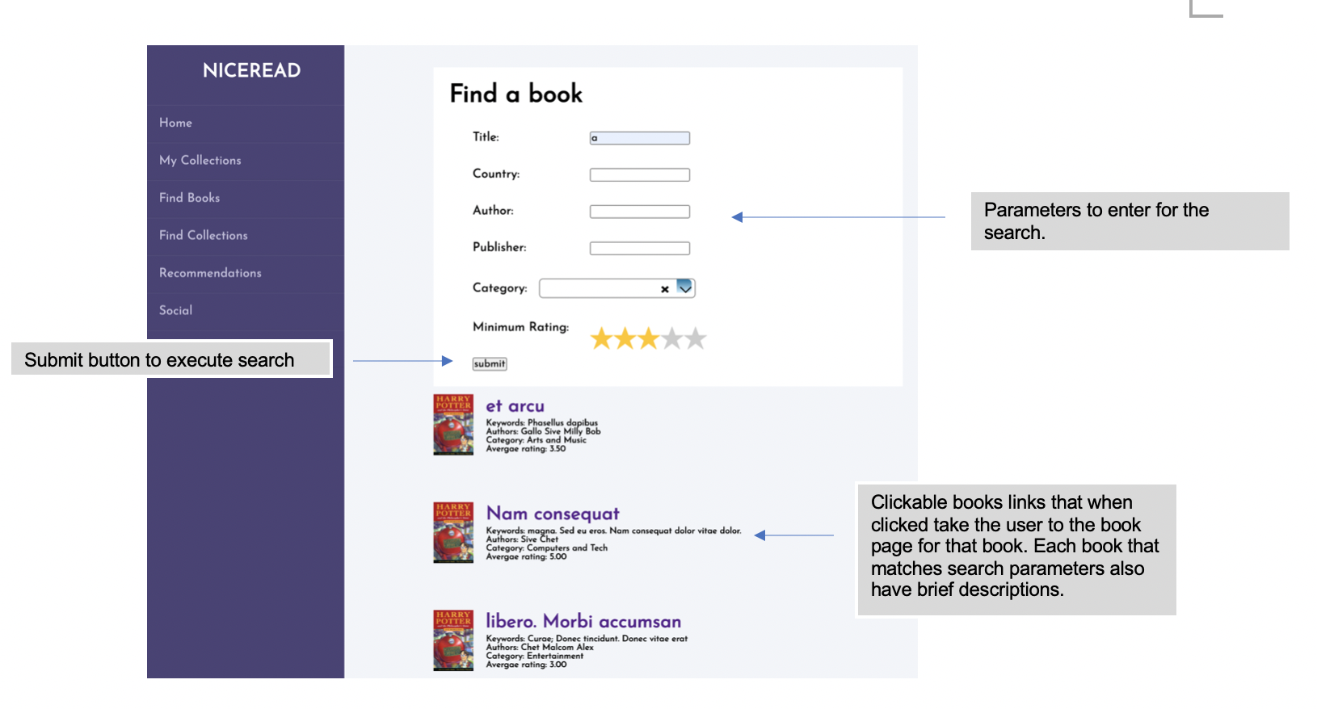

## Search collections page

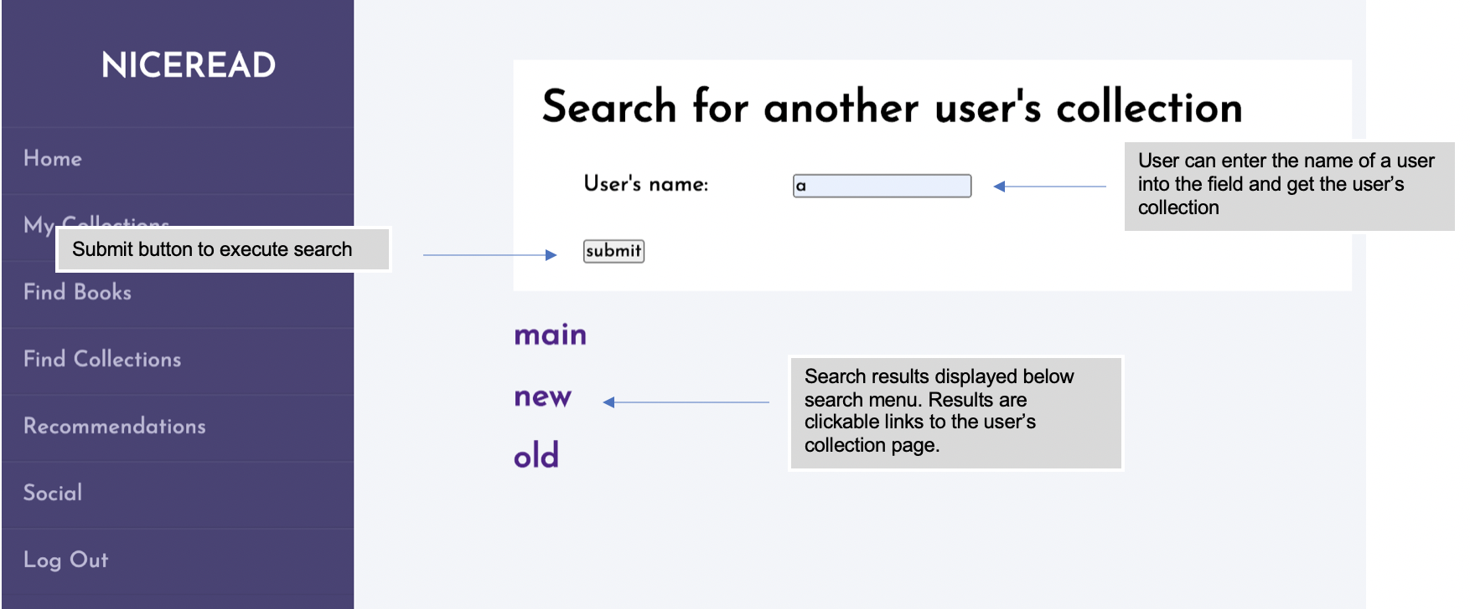

## Other users collections page

Modified standard collection page with the add and remove book options, which aren’t available if the collection isn’t yours.

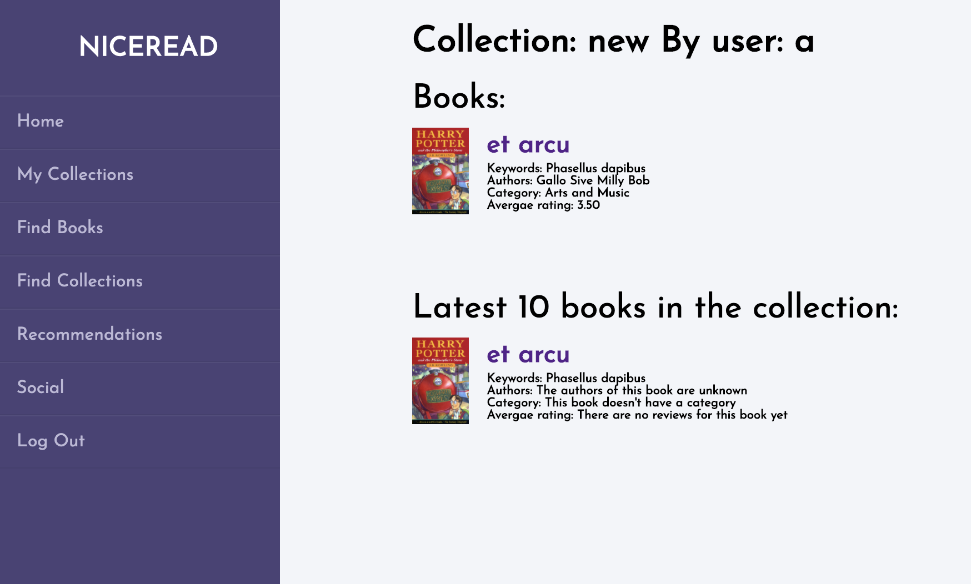

## Recommendation search page

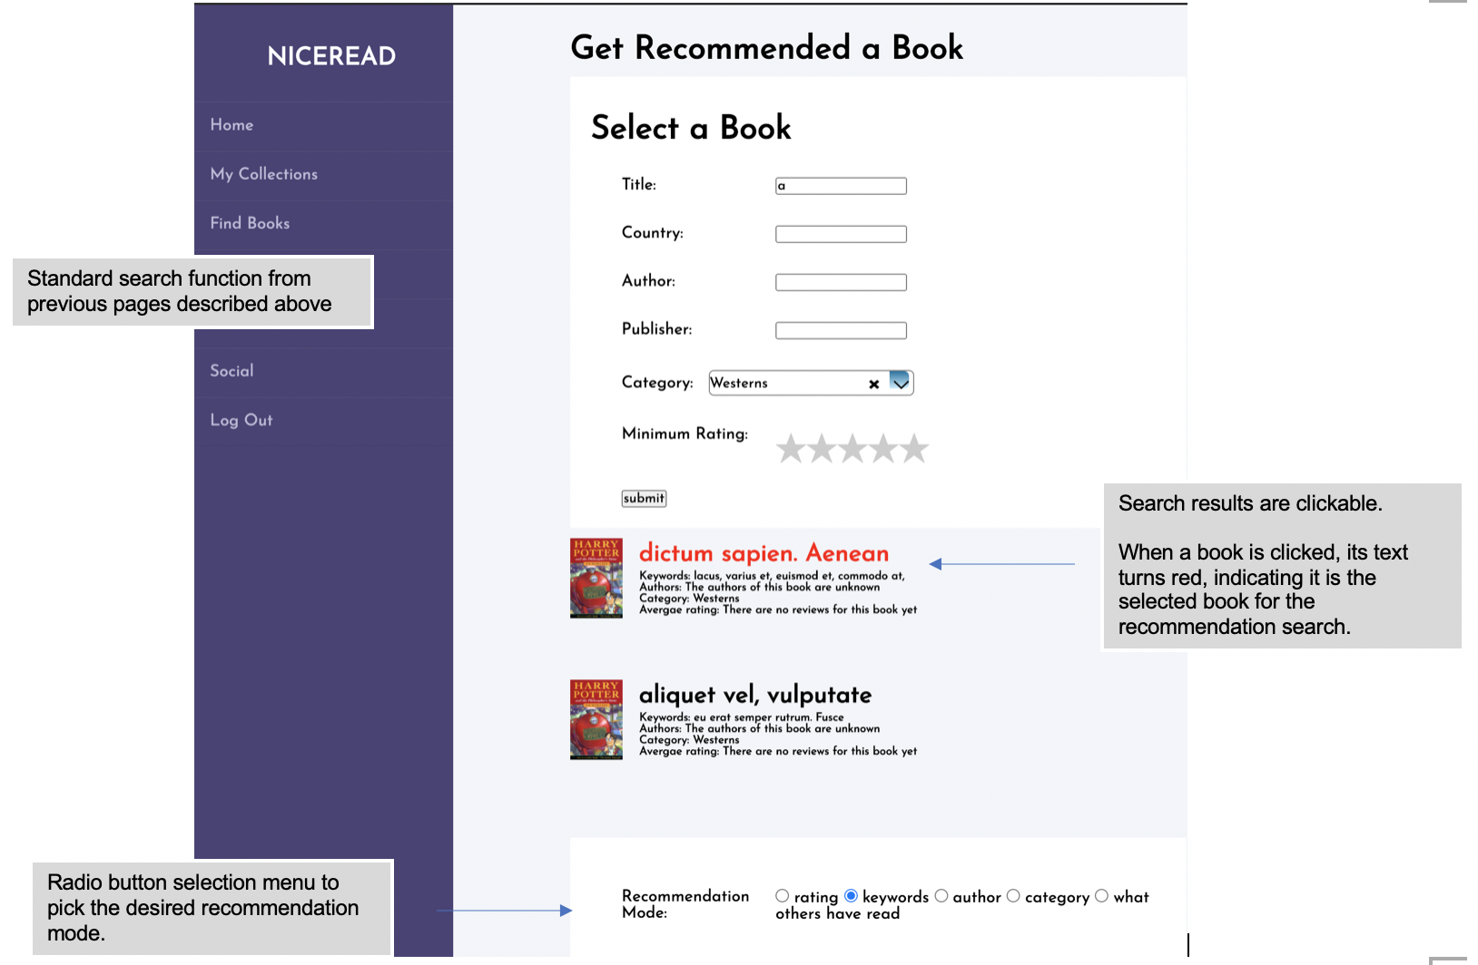

## Recommendation search page continued

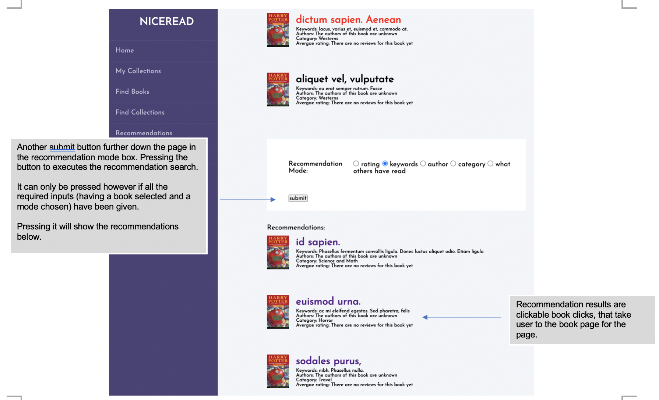

## Social home page

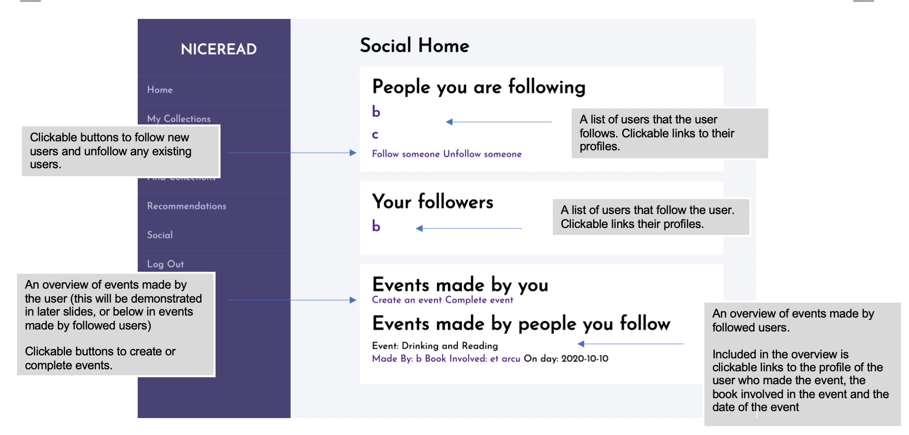

## Add follower page

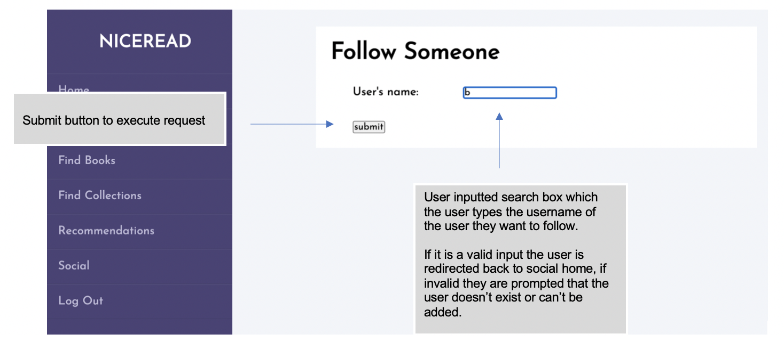

## Unfollow user prompt

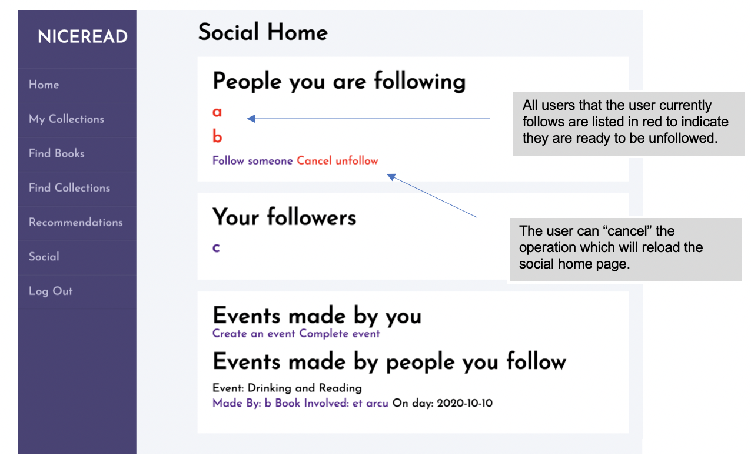

## Create event page

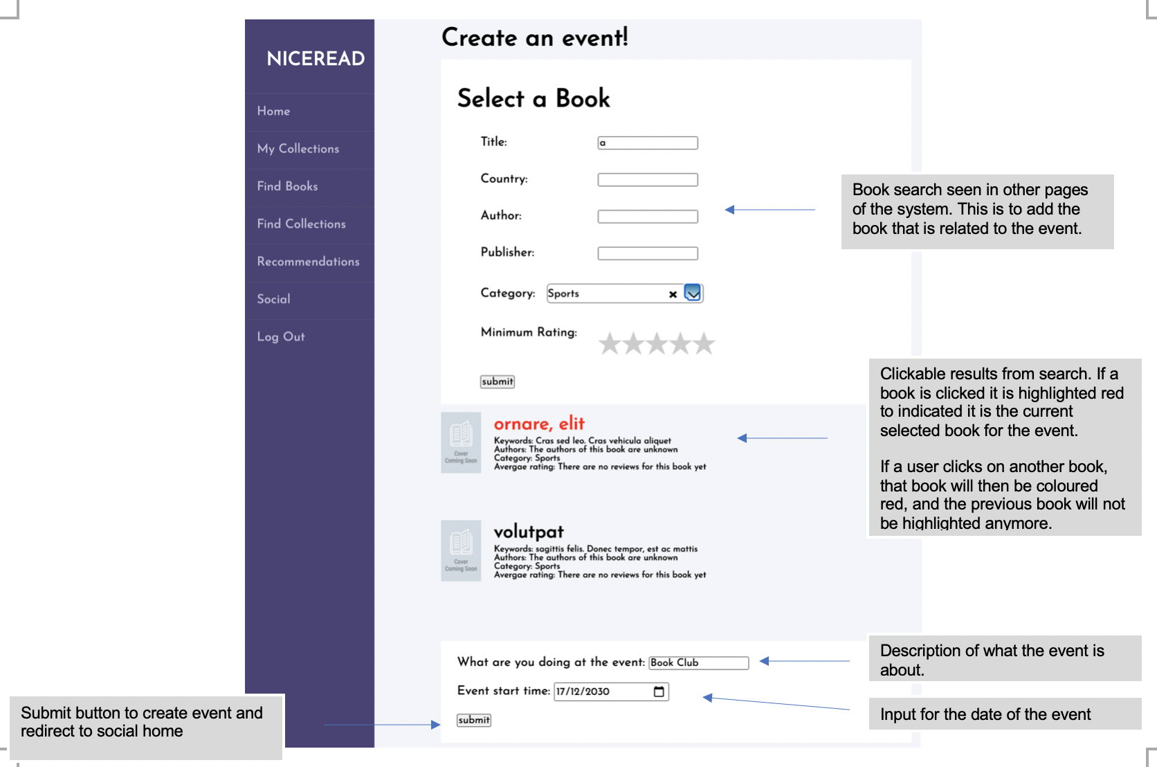

## Complete event prompt

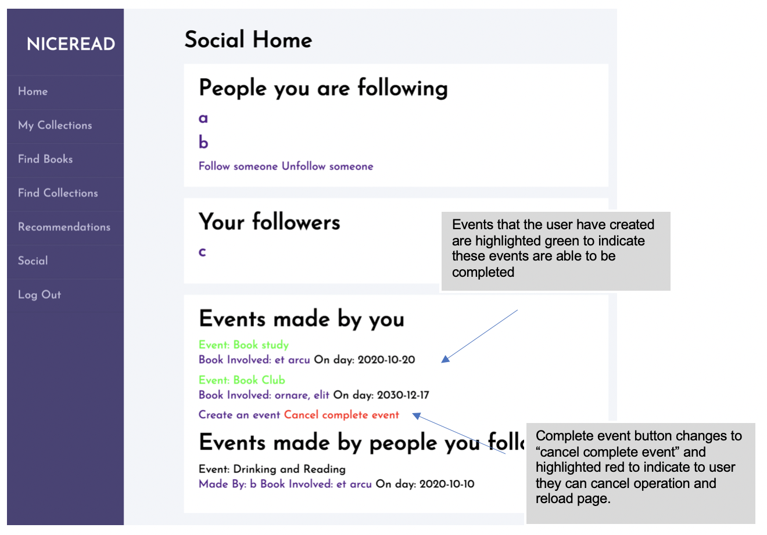

References

Citations for third party libraries and functionalities:

AnyChart. 2020. *Anychart Is A Lightweight And Robust Javascript Charting Library*. [online] Available at: <https://www.anychart.com/> [Accessed 6 August 2020].

GitHub. 2020. *Axios/Axios*. [online] Available at: <https://github.com/axios/axios> [Accessed 6 August 2020].

Select2.org. 2020. *Getting Started | Select2 - The Jquery Replacement For Select Boxes*. [online] Available at: <https://select2.org/> [Accessed 6 August 2020].

Numpy.org. 2020. *Numpy*. [online] Available at: <https://numpy.org/> [Accessed 6 August 2020].

Pandas.pydata.org. 2020. *Pandas - Python Data Analysis Library*. [online] Available at: <https://pandas.pydata.org/> [Accessed 6 August 2020].

Sqlite.org. 2020. *Sqlite Home Page*. [online] Available at: <https://www.sqlite.org/> [Accessed 6 August 2020].

Flask.palletsprojects.com. 2020. *Welcome To Flask — Flask Documentation (1.1.X)*. [online] Available at: <https://flask.palletsprojects.com/> [Accessed 6 August 2020].

Flask-restplus.readthedocs.io. 2020. *Welcome To Flask-Restplus’S Documentation! — Flask-Restplus 0.13.0 Documentation*. [online] Available at: <https://flask-restplus.readthedocs.io/en/stable/> [Accessed 6 August 2020].

Pyjwt.readthedocs.io. 2020. *Welcome To Pyjwt — Pyjwt 1.7.1 Documentation*. [online] Available at: <https://pyjwt.readthedocs.io/en/latest/> [Accessed 6 August 2020].